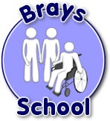Brays School Administering Medicine Form
The school will not give your child medicine unless you complete and sign this form
Name of child
Date of birth
Group/class/form
Medical condition or illness
Medicine
Name/type of medicine (as described on the container)
Expiry date
Dosage and method
Timing
Special precautions/other instructions
Are there any side effects that the school/setting needs to know about?
Procedures to take in an emergency
NB: Medicines must be in the original container as dispensed by the pharmacy (with the label)

Contact details
Name
Daytime telephone number
Relationship to child
Address

The above information is, to the best of my knowledge, accurate at the time of writing and I give consent to The Bridge School staff administering medicine in accordance with the School Administering Medicine policy. I will inform the School immediately, in writing, if there is any change in dosage or frequency of the medication or if the medicine is stopped.
Signature: | Date:

